Leptodirus hochenwartii Genome Assembly
Note: All the figures were generated using ‘assembly_plots.py’
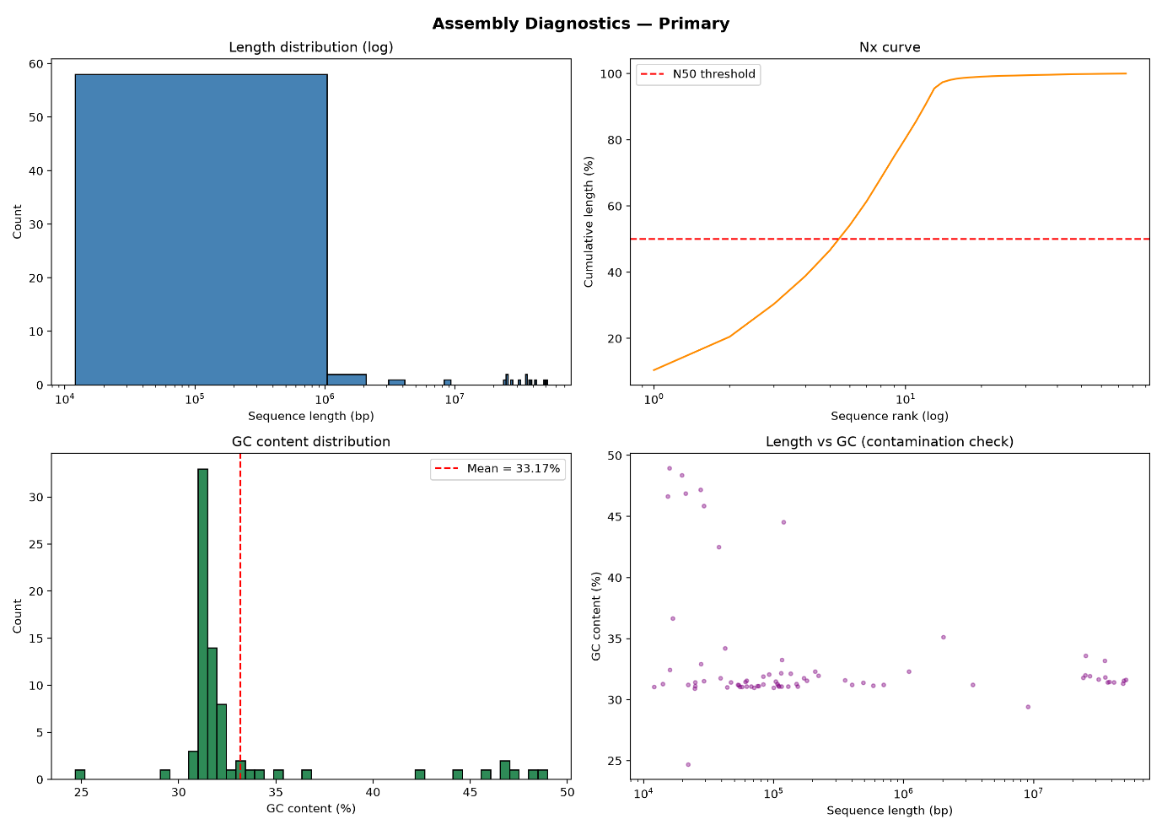
Figure 1: Primary Assembly (Leptodirus hochenwartii). Panel A shows length distribution, Panel B shows Nx curve, Panel C shows GC content distribution, and Panel D compares the length to GC.

Length Distribution (log scale) – We can see the sequences distributed across the different lengths, with majority of the counts sitting below 10⁵ bp, while a small amount is spread across the longer lengths.
Nx Curve – There is a gradual rise in the sequence ranks with an increase in length which then plateaus when it reaches a 100%. The rise confirms the chromosome level contiguity.
GC Content Distribution – A dominant peak at 32% GC content is observed while there were significant drops in the count at 33% and 34%. Clusters of small peaks can be seen spread throughout the graph. The dominant peak is consistent with the expected ~32% GC content. However, the other smaller clusters could be considered as discrepancies.
Length vs GC Scatter – A large cluster can be seen along the 32% GC content with lengths between 10⁴ to 10⁵ bp. Other points can also be seen spread across the entire graph. Such a mixed result can be due to the dominant organism having a small set of sequences with a divergent base composition.

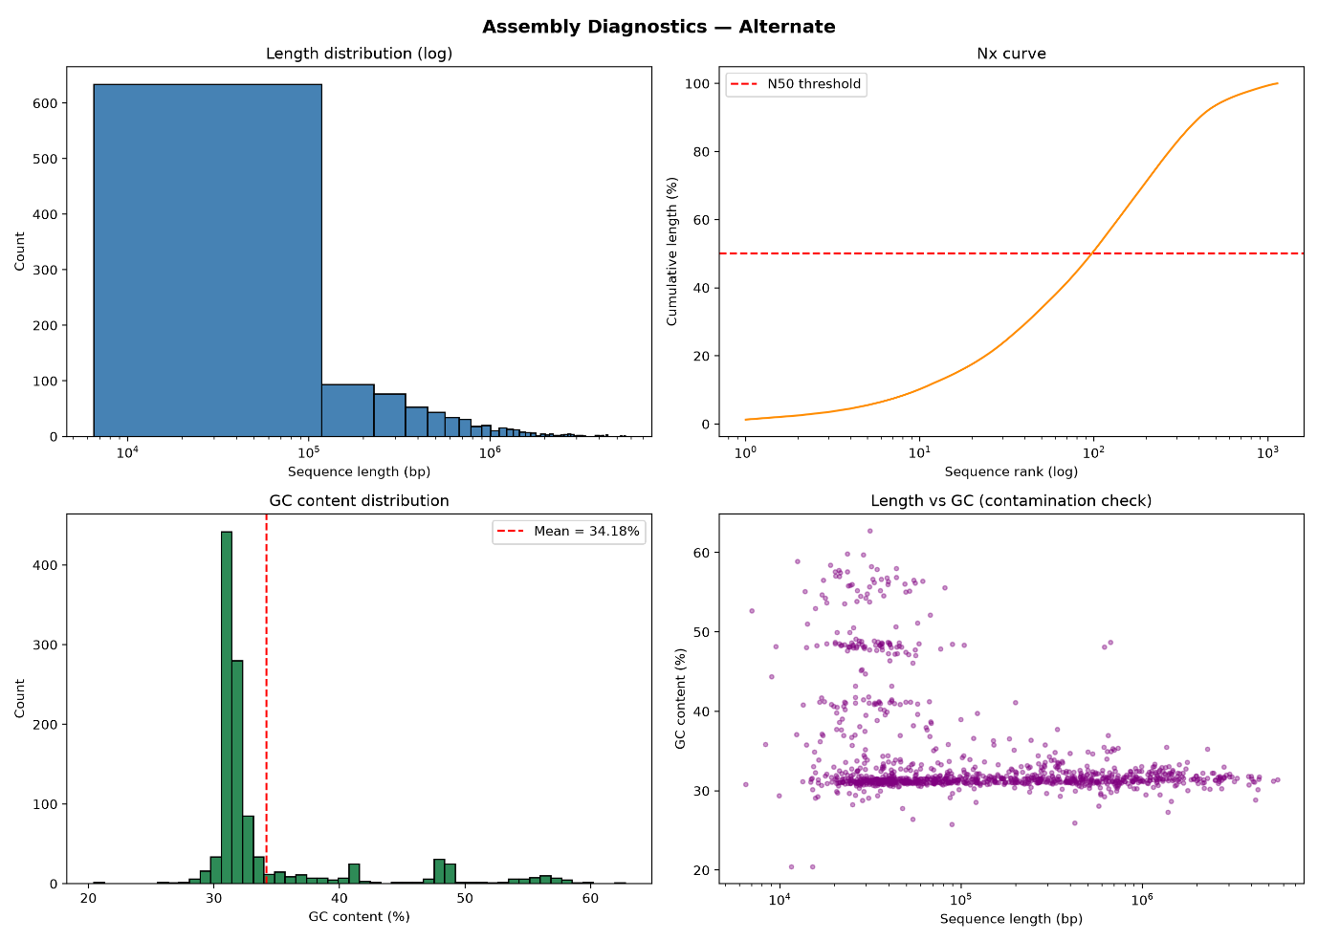
Figure 2: Alternate Assembly (Leptodirus hochenwartii – Alternate Haplotype). Panel A shows length distribution, Panel B shows Nx curve, Panel C shows GC content distribution, and Panel D compares the length to GC.

Length Distribution (log scale) – The sequence length of between 10⁴ to 10⁵ has a consistent count of 650 with a gradual decrease with longer lengths. This was expected as the alternate haplotype only contains heterozygous regions that could not collapse into the primary.
Nx Curve – The graph shows a gradual rise with it plateauing at around 98% length.
GC Distribution – Peak of around 450 counts can be seen at 32% GC count. This shows a stronger signal than in the primary.
Length vs GC Scatter – GC cluster is most dense at the 32% mark and it continues to decrease as the GC content increases. The other clusters could be a whole other population of sequences with completely different base composition.

Interpretation
The Leptodirus hochenwartii primary assembly has a high-quality, chromosome-level reference. The Nx curve, L50 = 6, and scaffold N50 of 37.27 Mb match the values defined by the Earth Biogenome Project, and NCBI's reported metadata, which confirms the integrity of files.
The figures prove excellent contiguity and gross compositional structure. Although, they do not prove base accuracy, gene completeness, structural correctness, or absence of a minor contaminant population. The high-GC cluster should be further analysed and compared with the published QV/BUSCO values to provide complementary evidence.

